BASSEY, BASSEY ENANG
OFFICE MANAGEMENT
Summary
Seeking a challenging and fast-paced role where I can leverage my skills and experience to make significant impact, excited to contribute to an organization that values continues learning and growth.

EDUCATION
Bachelor of science 0ct, 2020-0ct, 2025
University Of Cross River State, Okuku campus
Faculty of Basic Medical Sciences (Human physiology)

Senior School Certificate Examination Sept, 2014-may2019
Community Secondary Commercial School Ekunkune, Assiga Old Town

EXPERIENCES
Nicholas Obo Global Ventures Sept 2018- Aug. 2020
- Overseeing the activities of poultry farm and store room
- Taking care of inventory records
- In charge of procurement and finally given the overall turn up of the circle

B2 Enang Global Enterprise July, 2023-sept, 2025
Administrative personnel
- Attending to people both old and young
- Offering possible solutions bridging the gap of a sale representative and customer care
Hope Spring Clinic And Diagnostic Center April, 2024-Aug, 2025
ECG Technician
-Scan room technician in charge of the Electro Cardiograph unit

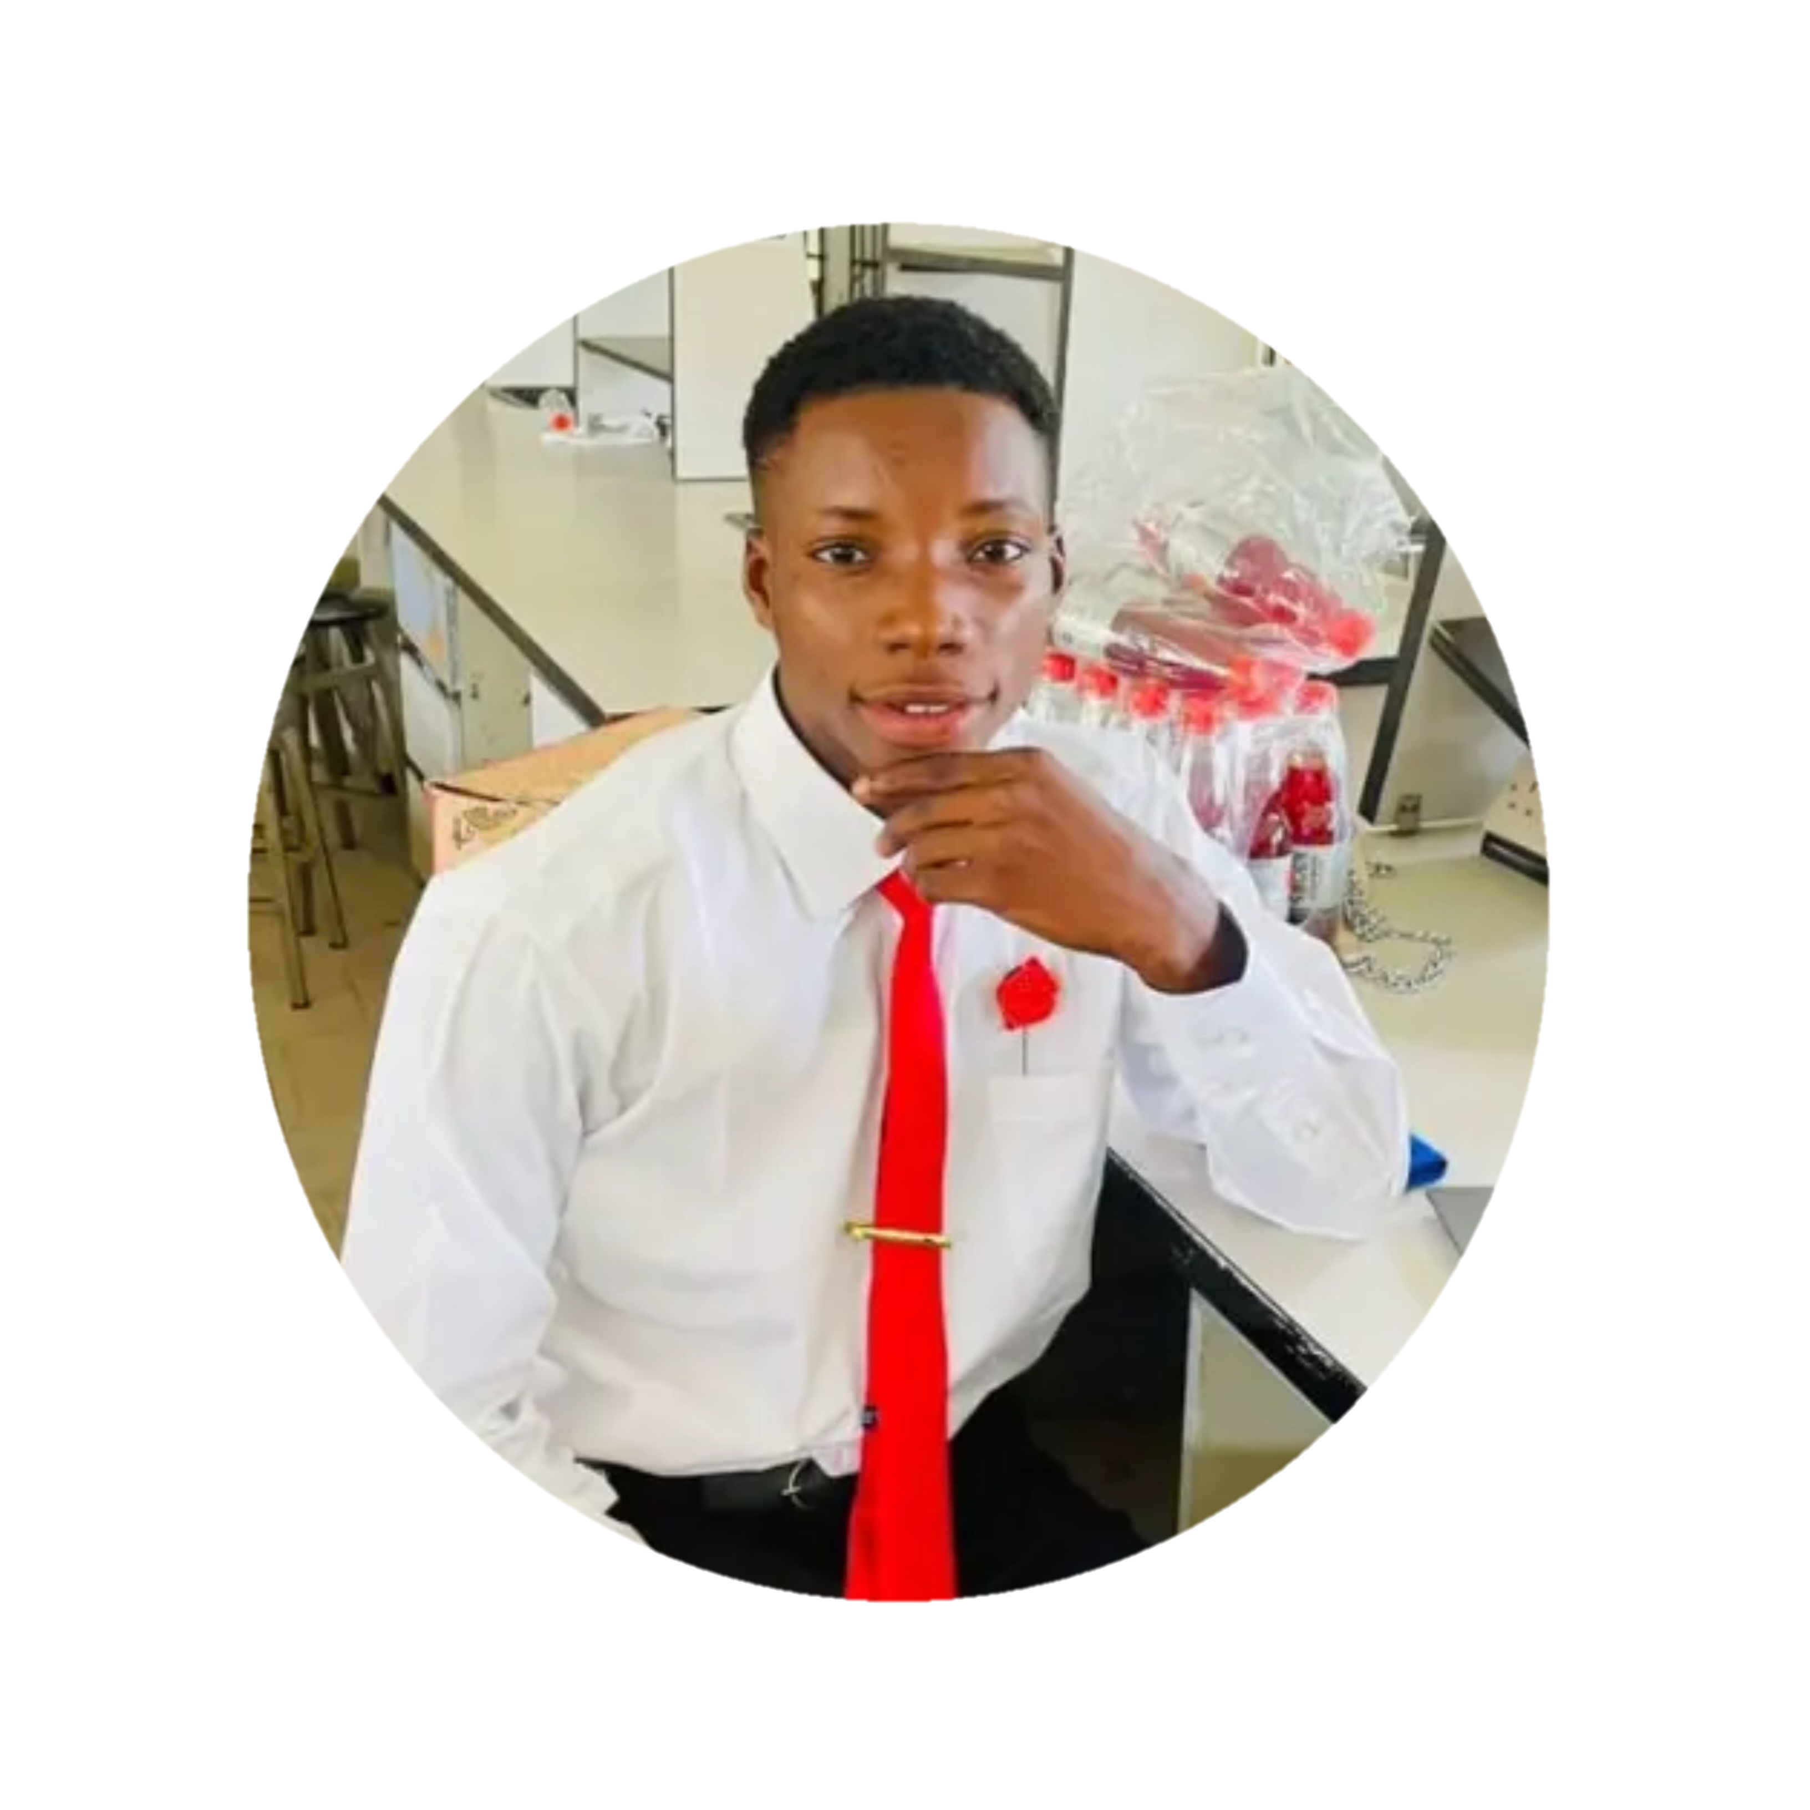CONTACT DETAILS
Phone:07069054667, 09039769283
EMAIL: bassyenang92@gmail.com
NATIONALITY:
Nigerian
DOB:25-5-2002
GENDER:Male
ADDRESS:
No. 20 Atamunu Street Calabar, Cross River State
SKILLS
- Ability to work effectively in a team
- Ability to work under pressure with no supervision.
- Good inter-personal relation, team player
- Good computer skill
- Effective communication.
REFEREES:
Mr. Ferdinand Bassey Sunday
08066050998
Mrs. Ayiga, Ogum Usang
08163421487

